OP Art – Optical / illusion

Information

Abstract work, typically black and white, portrays the idea of movement, hidden images, swelling, vibrating and flashing.

Links back to Neo-Impressionism, cubism, futurism and constructivism

Major connection to Kinetic art which relies on movement which perceivable by the audience.

Places Visited

Oldest visitor attraction in Edinburgh, 1835, filled with illusions

<https://www.camera-obscura.co.uk/>

Ideas

The Kinetic Chandelier in Leningrad,

A collaboration by Ascreen Group Comapnt, Timeline and Atlantic Star.

It is made up of over 1,000 LED’s that change colour and position during the performance.

<http://www.rightthisminute.com/video/rtmtv-kinetic-chandelier-leningrad-both-magical-beautiful>

<https://www.fastcompany.com/3045288/the-chandelier-of-the-future-is-made-from-1100-moving-leds>

Asinas 2015 – Jennifer Townley

Mechanical sculpture with smooth natural motion, representing simple angular geometric shapes.

Three straight line segments joined on at 90 degrees

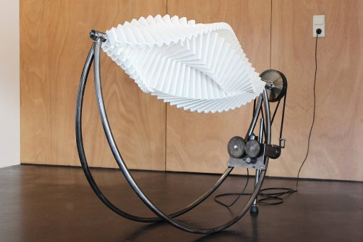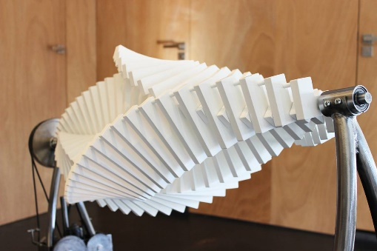<http://www.jennifertownley.com/asinas>